Vibs Example - 5DOF Lumped Mass Shear Beam 1
Beam Parameters 1
Build Beam 2
Eigen Solution 2
Form Residues 4
THMPER Scenario - full 5
Complex Mode Indicator Function 5
Shape Estimation 6
Plot tracked cmif 9
Pole Estimation 10
H11 Synthesis 13
H15 Synthesis 16
Modal Flexibility 19
Print results 21

Vibs Example - 5DOF Lumped Mass Shear Beam
Beam Details and Analysis
jdv 06232015; 07232015; 08162015; 11122015; 11142015
clear all

Beam Parameters
% section
b = 1; % in
h = 12; % in
I = b*h^3/12; % in^4
A = b*h; % in^2
E = 29e6; % psi
% geometry
L = 100*12; % ft -> in; total length
nn = 5; % number of inner dof (discretization)
nel = nn+1; % number of beam elements
mchk = 1; % 1 = lumped mass, else = continuous
% mass
ro = .29; % density [lb/in^3]
grav = 386.4; % in/sec^2;
mbar = A*ro; % lbf/in - weight
mbar = mbar/grav; % lbm/in (m = f/a)

Build Beam
% build bernoulli beam
[K,M] = beam_builder(E,I,L,nel,mbar,mchk);
% make shear beam
% -remove rotation dof
ind = 2:2:length(K);
K = removerows(K,'ind',ind);
K = removerows(K','ind',ind);
M = removerows(M,'ind',ind);
M = removerows(M','ind',ind);

Eigen Solution
[V,D] = eig(K,M); % solve
[val,ind] = sort(diag(D)); % sort eigenvalues
V = V(:,ind); % apply sort to eigenvectors
W = sqrt(val); % [rad/sec]
F = W/2/pi; % [hz]
% decouple system matrices
Mr = V'*M*V; % modal mass, Mr
Kr = V'*K*V; % modal stiffness, Kr
% form mass normalized modeshapes
Vn = zeros(size(V));
ne = size(V,2); % number of effective modes
for ii = 1:ne
Vn(:,ii) = V(:,ii)/sqrt(Mr(ii,ii));
end
% get scaled modal mass and stiff
Mr = Vn'*M*Vn;
Kr = Vn'*K*Vn;
% add proportional damping
dampr = [.05 .05 .05 .05 .05]' % damping ratio [% critical damping]
dampf = -dampr.*W; % damping factor [rad/sec]
Wn = sqrt(W.^2 + dampf.^2) % damped natural frequency [rad/sec]
root = dampf + 1j.*Wn % form positive poles
F = Wn/2/pi % frequencies [hz]
% define modal scaling for unit mass
% notes: -true unity mass due to mass normalize eigenvector
% -5 modes solved for
Qr = 1./(2j.*diag(Mr).*Wn)
dampr =
0.0500
0.0500
0.0500
0.0500
0.0500
Wn =
30.5639
59.0448
83.5020
102.2687
114.0659
root =
1.0e+02 *
-0.0153 + 0.3056i
-0.0295 + 0.5904i
-0.0417 + 0.8350i
-0.0511 + 1.0227i
-0.0570 + 1.1407i
F =
4.8644
9.3973
13.2898
16.2766
18.1541
Qr =
0.0000 - 0.0164i
0.0000 - 0.0085i
0.0000 - 0.0060i
0.0000 - 0.0049i
0.0000 - 0.0044i

Form Residues
Get residue [A]r for each mode r from eigenvectors to form partial fraction expansion
% form radial frequency vector
ns = 2^9; % number of spectral samples
w = linspace(-150,150,ns); % [rad/sec]
inLoc = 1:5; % index for input locations (columns of H)
outLoc = 1:5; % index for output locations (rows of H)
no = length(outLoc); % number of outputs
ni = length(inLoc); % number of inputs
ne = 5; % number of effective modes
% get FRF via residues
AA = zeros(no,ni,ns); HH = zeros(no,ni,ns);
for ii = 1:ne % loop modes
% form [A] for mode ii -> [no x ni x ns]
AA(:,:,ii) = Qr(ii) * V(:,ii) * V(:,ii)';
for jj = 1:no % loop outputs
for kk = 1:ni % loop inputs
out = outLoc(jj); % output DOF index
in = inLoc(kk); % input DOF index
for ll = 1:ns % loop spectral lines
% form [H] - add mode ii contribution -> [no x ni x ns]
% complex conjugate
tt = AA(out,in,ii) ./ (1j*w(ll) - root(ii)) + ...
conj(AA(out,in,ii))./(1j*w(ll) - conj(root(ii)));
% add each mode for total response
HH(jj,kk,ll) = HH(jj,kk,ll) + tt;
end
end
end
end
% convert HH [no x ni x ns] -> H [ns x no*ni] (legacy format)
H = zeros(ns,no*ni);
hInd = 1:no*ni;
hInd = reshape(hInd,no,ni);
for ii = 1:ns
for jj = 1:no
for kk = 1:ni
H(ii,hInd(jj,kk)) = HH(jj,kk,ii);
end
end
end

THMPER Scenario - full
use full FRF
nn = 5; % number of global dof to include
in = 1:5; % global ref of input dof index
out = 1:5; % global ref of output dof index
% find common dof between U and V
dp = meta_dp(out,in)
dp =
nr: 5
id: 1
in: [1 2 3 4 5]
out: [1 2 3 4 5]

Complex Mode Indicator Function
% sort frf
[hh,out,in] = frf_sort(HH,out,in);
% find frequency index for roots
[~,peakLoc] = searchVector(w,Wn);
% add rank = 1
rank = ones(size(peakLoc));
% % - mode 4 override peak
% [~,tt] = searchVector(w,103);
% peakLoc(4) = tt;
%
% % - mode 5 slightly lagging, override to peak
% [~,tt] = searchVector(w,115.9);
% peakLoc(5) = tt;
%
% rank(5) = 2;
% get cmif
[uu,ss,vv] = cmif_svd(hh);
% plot cmif
fh = figure; ah = axes;
fh.PaperPositionMode = 'auto';
fh.Position = [100 100 1300 600];
cmif_plot(ah,w,ss,[0 150],peakLoc,rank);
lh = findobj(ah.Children,'type','line');
set(lh,'linewidth',1.5,'markersize',12);
snapnow
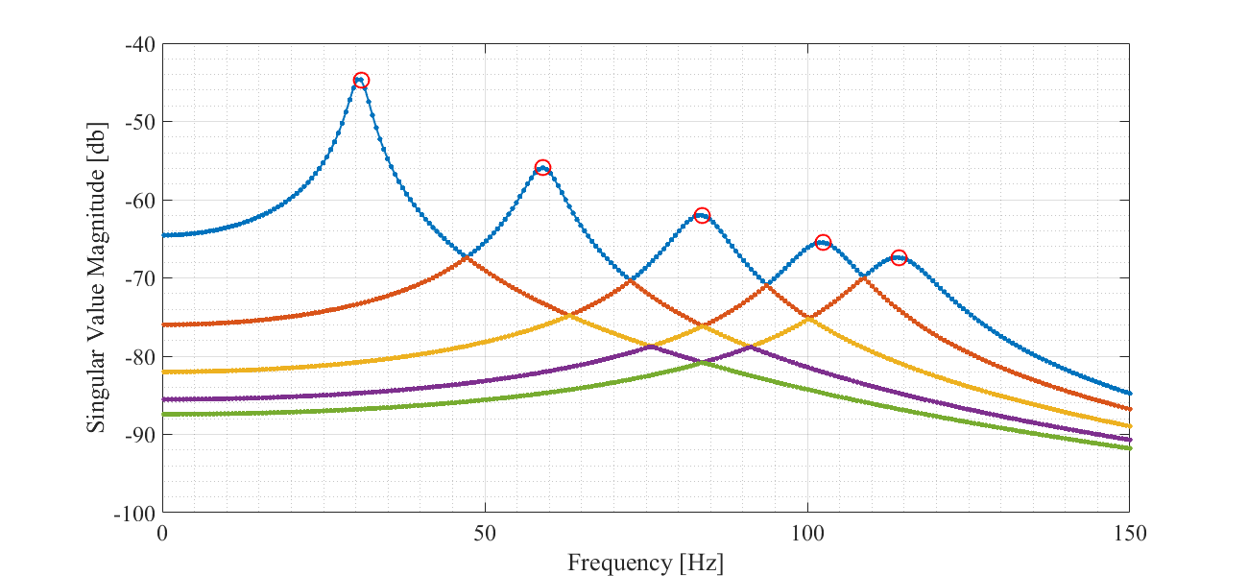

Shape Estimation
% get shapes
[U,L,Lm,msf] = cmif_getshapes(uu,vv,dp.out,dp.in,peakLoc,rank)
% create figure
fh = figure; ah = axes;
fh.PaperPositionMode = 'auto';
fh.Position = [50 250 1300 600];
% compare to eigenvector
for ii = 1:5
fprintf('Mode: %d\n',ii);
y1 = V(:,ii); % eigenvector
y2 = U(:,ii); % largest dimension
% plot modes
beam_plotshape2(ah,y1,y2,out,100*12,nn);
th = title(['Mode: ' num2str(ii)],...
'fontweight','normal',...
'fontsize',26);
snapnow
end
Getting shapes... Done.
U =
0.5000 1.0000 1.0000 1.0000 0.5000
0.8660 1.0000 0.0000 -1.0000 -0.8660
1.0000 0.0000 -1.0000 -0.0000 1.0000
0.8660 -1.0000 -0.0000 1.0000 -0.8660
0.5000 -1.0000 1.0000 -1.0000 0.5000
L =
-0.2887 -0.5000 0.5774 0.5000 0.2887
-0.5000 -0.5000 0.0000 -0.5000 -0.5000
-0.5774 -0.0000 -0.5774 -0.0000 0.5774
-0.5000 0.5000 -0.0000 0.5000 -0.5000
-0.2887 0.5000 0.5774 -0.5000 0.2887
Lm =
0.5000 1.0000 1.0000 1.0000 0.5000
0.8660 1.0000 0.0000 -1.0000 -0.8660
1.0000 0.0000 -1.0000 -0.0000 1.0000
0.8660 -1.0000 -0.0000 1.0000 -0.8660
0.5000 -1.0000 1.0000 -1.0000 0.5000
msf =
-1.7321 -2.0000 1.7321 2.0000 1.7321
Mode: 1
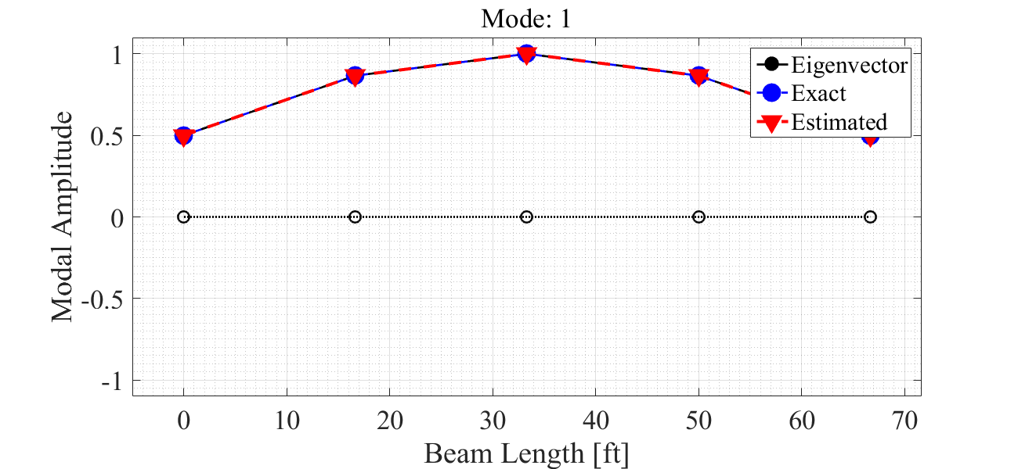
Mode: 2
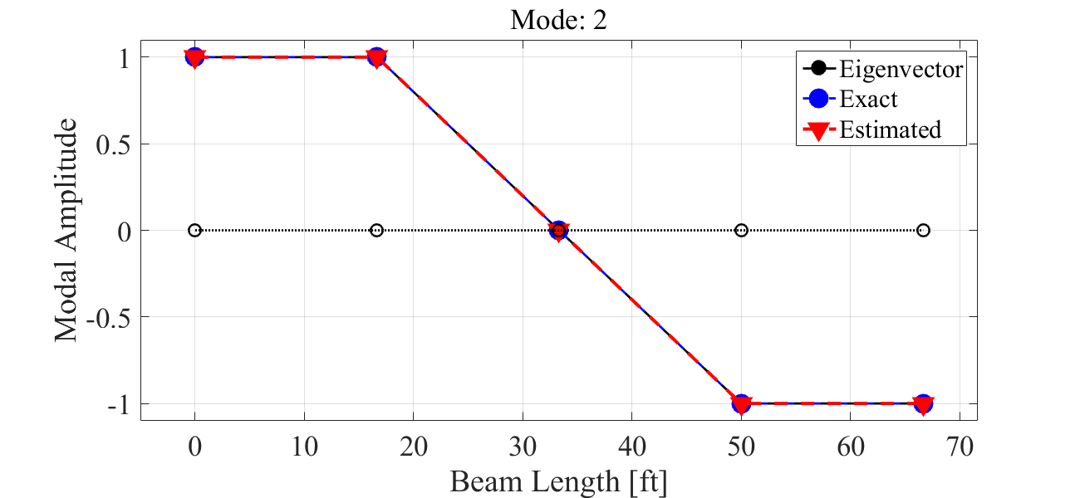
Mode: 3
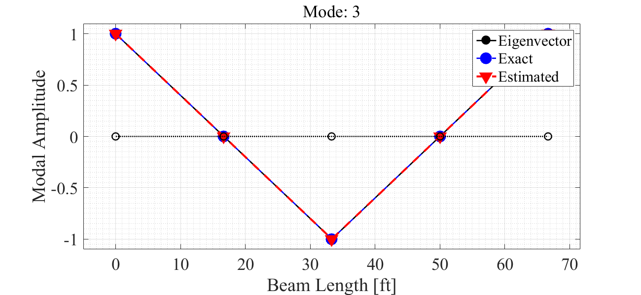
Mode: 4
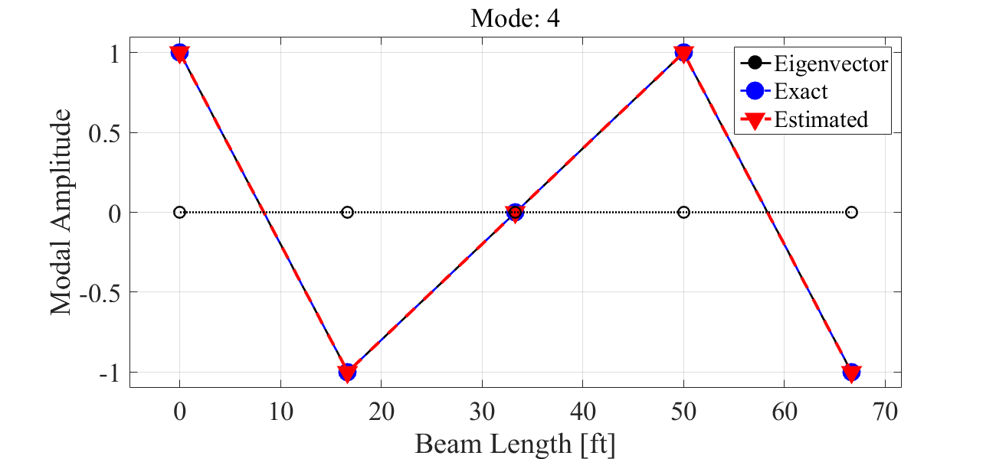
Mode: 5
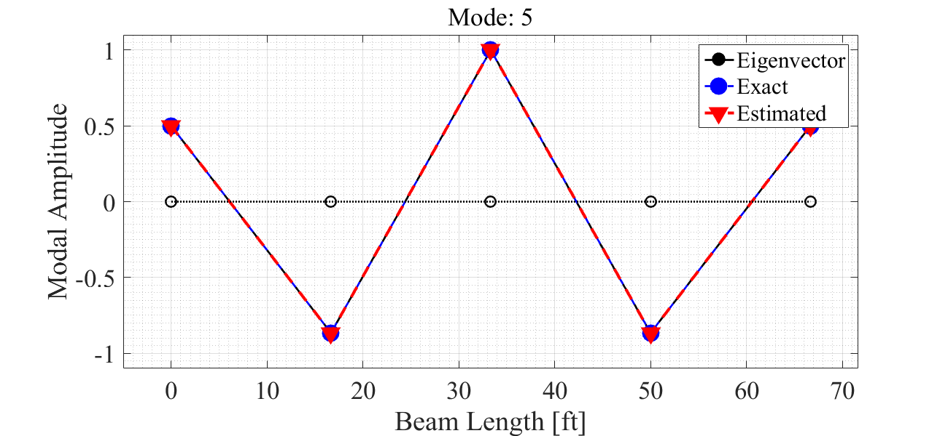

Plot tracked cmif
fh = figure; ah = axes;
fh.PaperPositionMode = 'auto';
fh.Position = [25 250 1300 600];
lb = 5; rb = 145; thresh = .7;
Sk = trackShapes(L,ss,vv,peakLoc,w,lb,rb,thresh);
% plot
[~,bnds] = searchVector(w,[lb rb]);
ph = plot(ah,w(bnds(1):bnds(2)),mag2db(Sk),'.-');
set(ph,'linewidth',1.5,'markersize',12);
lg = [];
for ii = 1:size(L,2)
lg{ii} = ['Shape ' num2str(ii)];
end
legend(ah,lg);
set(ah,'fontsize',18, 'fontname','times new roman');
grid(ah,'on'); grid(ah,'minor');
xlabel('Frequency [Hz]');
ylabel('Singular Value Magnitude [db]');
snapnow
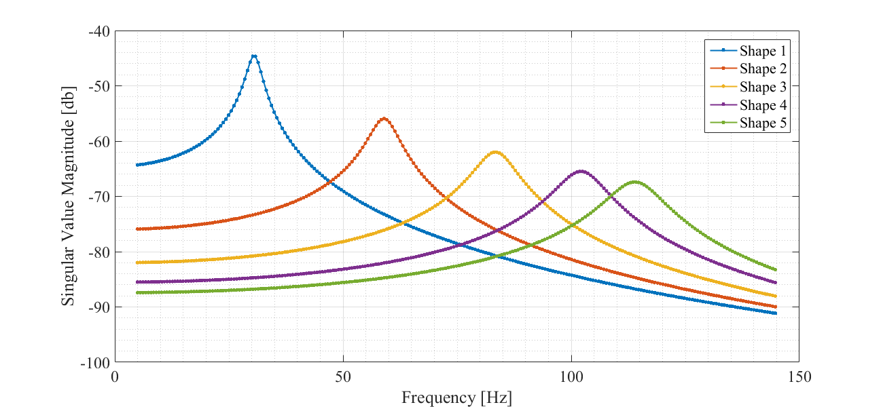

Pole Estimation
% default fit parameters
noterms = ones(size(peakLoc))*5;
nob = ones(size(peakLoc))*3;
% get poles
[eH,pols,frdmp,qr,ma,ehs] = cmif_getpoles(hh,U,Lm,dp,w/2/pi,peakLoc,noterms,nob);
% plot efrf
fh = figure; ah = axes;
fh.PaperPositionMode = 'auto';
fh.Position = [100 100 1300 600];
for ii = 1:nn
fprintf('eFRF - Curve Fit - Mode %d\n',ii);
plot(ah,w,mag2db(abs(eH(:,ii))),'.-')
hold(ah,'all')
plot(ah,w,mag2db(abs(ehs(:,ii))),'--')
plot(ah,w(peakLoc(ii)),mag2db(abs(eH(peakLoc(ii),ii))),'ro');
hold(ah,'off');
xlim(ah,[0 150]);
xlabel(ah,'Frequency [Hz]');
ylabel(ah,'eFRF Magnitude [db]');
grid(ah,'on');
grid(ah,'minor');
th = title(ah,['Mode: ' num2str(ii) ' Frequency: ' num2str(imag(pols(ii))) ' Hz']);
set(th,'fontweight','normal');
set(ah,'fontname','times new roman','fontsize',18);
lh = findobj(ah.Children,'type','line');
lh(3).MarkerSize = 12;
snapnow
end
Getting poles... Done.
eFRF - Curve Fit - Mode 1
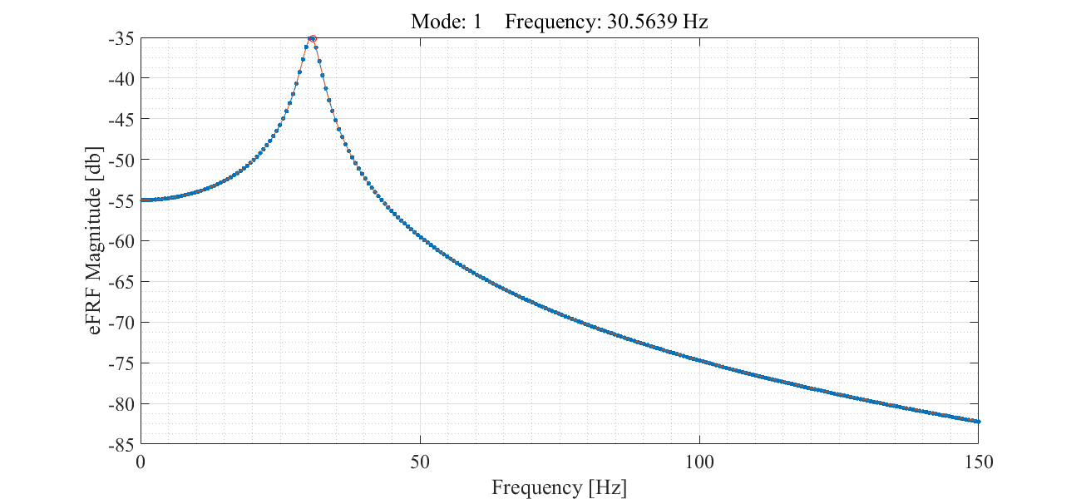
eFRF - Curve Fit - Mode 2
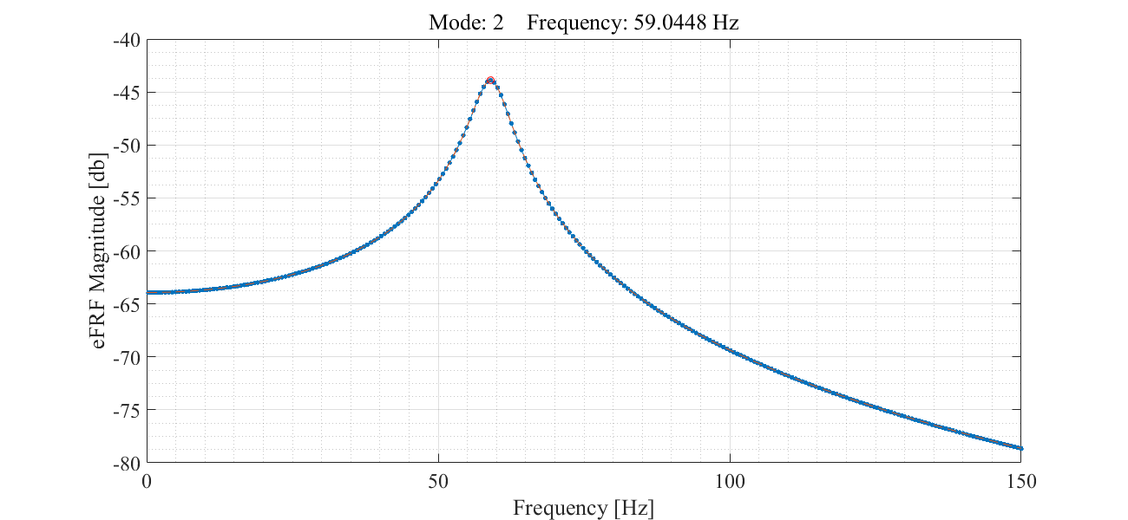
eFRF - Curve Fit - Mode 3
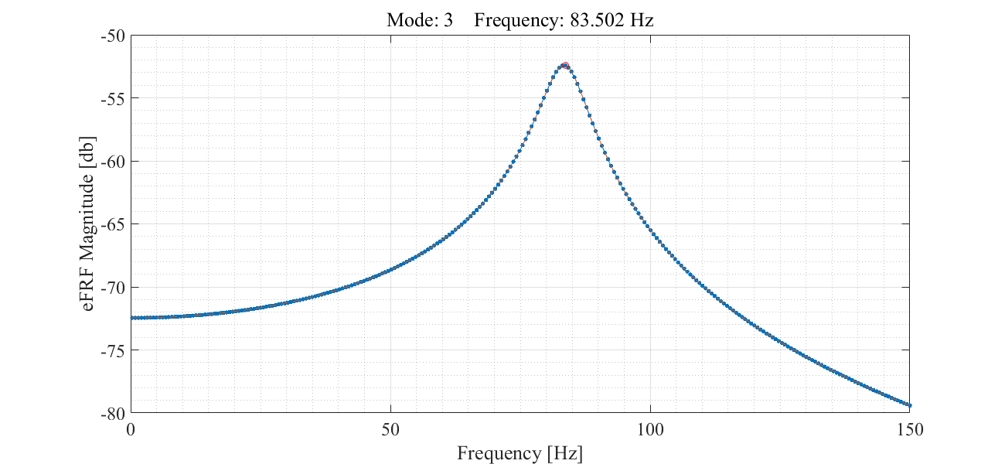
eFRF - Curve Fit - Mode 4
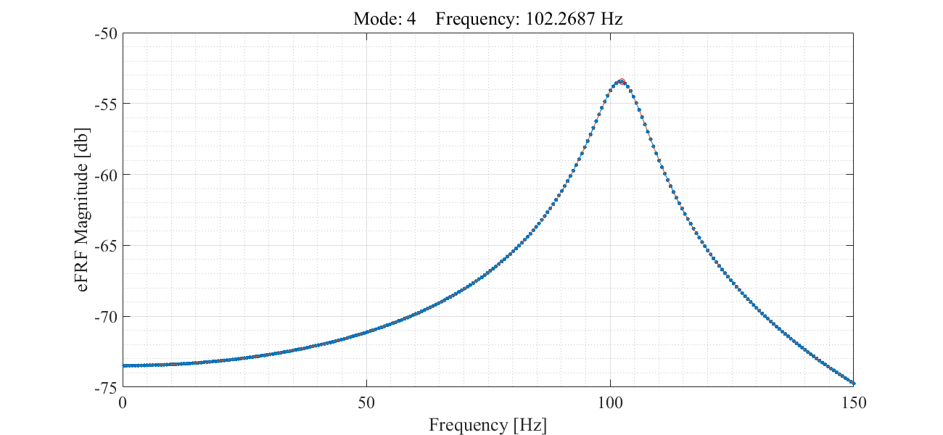
eFRF - Curve Fit - Mode 5
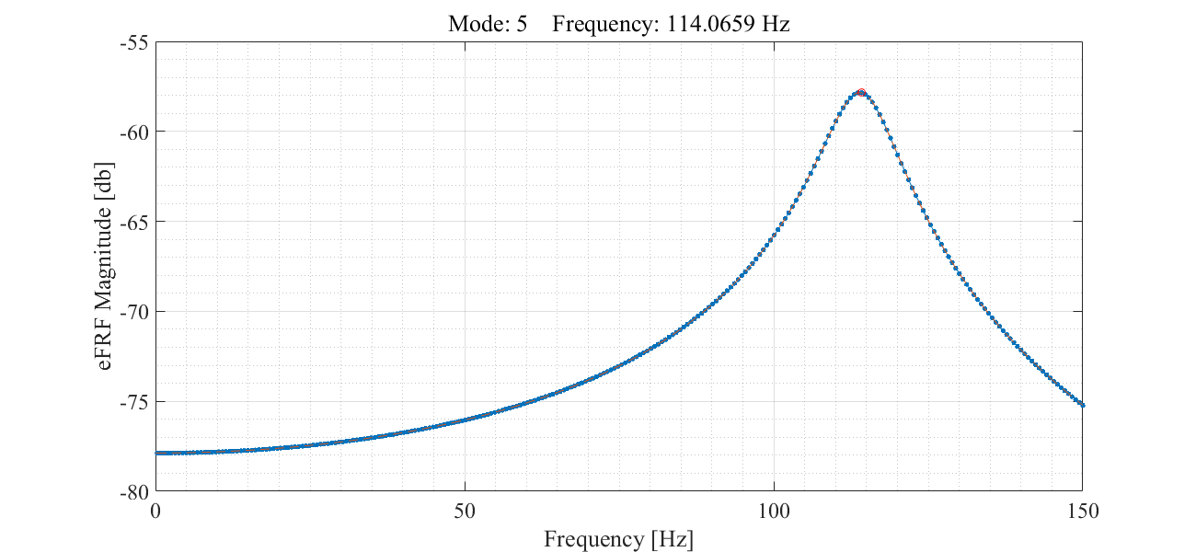

H11 Synthesis
insel = 1; % input dof index
outsel = 1; % output dof index
% FRF
fprintf('FRF\tOutput: %2d\tInput: %2d\n',out(outsel),in(insel));
% plot
[Hs,hs] = frf_synthesize(U,Lm,outsel,insel,qr,pols,w);
fh = vibsFRFplot(Hs,hs,insel,outsel,w);
hold all
% plot exact solution
% -note: outsel/insel used w/o out/in indexing
% bc hh already reduced from HH
ph = plot(fh.Children(2),w,mag2db(abs(squeeze(hh(outsel,insel,:)))),'o--r',...
'linewidth',2,...
'markersize',2,...
'displayname',['H' num2str(out(outsel)) num2str(in(insel)) ' - Actual']);
hold off
% get old strings
lh = fh.Children(1);
st = [lh.String {['H' num2str(out(outsel)) num2str(in(insel)) ' - Actual']}];
% append legend entry
st{1} = ['H' num2str(out(outsel)) num2str(in(insel)) ' - Estimated'];
legend(st);
snapnow
% Phase
fprintf('Phase\tOutput: %2d\tInput: %2d\n',out(outsel), in(insel));
% plot
[Hs,hs] = frf_synthesize(U,Lm,outsel,insel,qr,pols,w);
fh = vibsPhaseplot(Hs,hs,insel,outsel,w);
hold all
% plot exact solution
ph = plot(fh.Children(2),w,angle(squeeze(hh(outsel,insel,:)))*180/pi,'o--r',...
'linewidth',2,...
'markersize',2,...
'displayname',['H' num2str(out(outsel)) num2str(in(insel)) ' - Actual']);
hold off
% get old strings
lh = fh.Children(1);
st = [lh.String {['H' num2str(out(outsel)) num2str(in(insel)) ' - Actual']}];
% append legend entry
st{1} = ['H' num2str(out(outsel)) num2str(in(insel)) ' - Estimated'];
legend(st,'location','northeast');
snapnow
% Impulse Response Function
fprintf('IRF\tOutput: %2d\tInput: %2d\n', out(outsel), in(insel));
% plot
fs = 200; % sampling freq
l = .5; % length [sec]
[Hs,hs] = irf_synth(U,Lm,outsel,insel,qr,pols,fs,l);
fh = vibsIRFplot(Hs,hs,insel,outsel,fs,l);
hold all
% plot exact solution
h = [];
t = 0:1/fs:.5-1/fs;
for ii = 1:ne % loop poles
% get residue for mode ii
AA = Qr(ii) * V(:,ii) * V(:,ii)';
h(:,ii) = AA(out(outsel),in(insel)) * exp(pols(ii)*t) + ...
conj(AA(out(outsel),in(insel))) * exp(conj(pols(ii))*t);
end
h = sum(h,2);
ph = plot(fh.Children(2),t(1:length(h)),h,'o--r',...
'linewidth',2,...
'markersize',5,...
'markerfacecolor','r',...
'markeredgecolor','none',...
'displayname',['H' num2str(out(outsel)) num2str(in(insel)) ' - Actual']);
hold off
% get old strings
lh = fh.Children(1);
st = [lh.String {['H' num2str(out(outsel)) num2str(in(insel)) ' - Actual']}];
% append legend entry
st{1} = ['H' num2str(out(outsel)) num2str(in(insel)) ' - Estimated'];
legend(st);
snapnow
FRF Output: 1 Input: 1
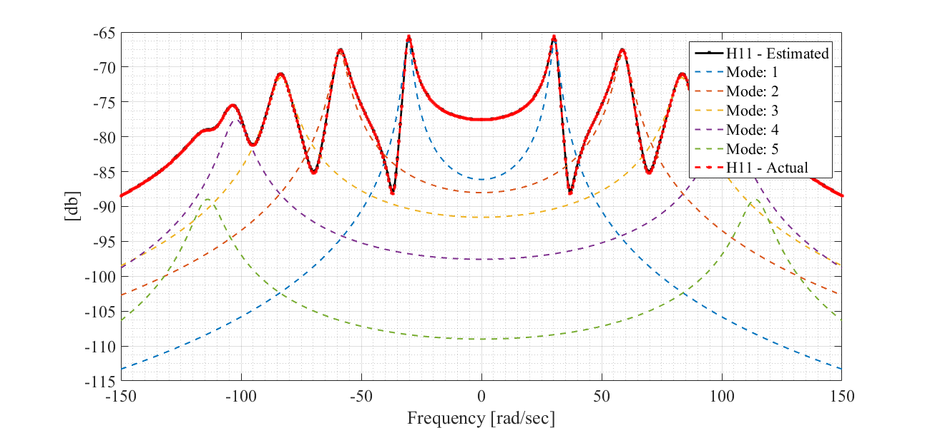
Phase Output: 1 Input: 1
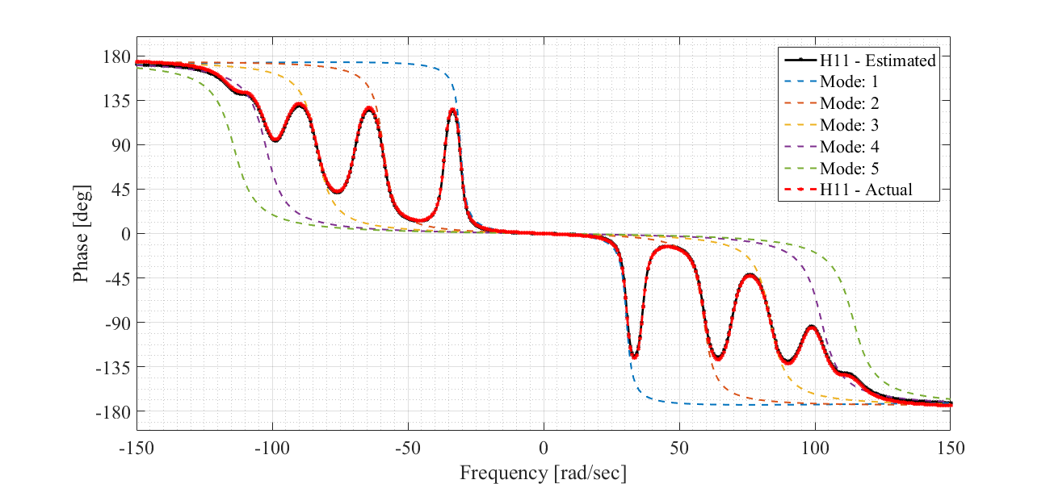
IRF Output: 1 Input: 1
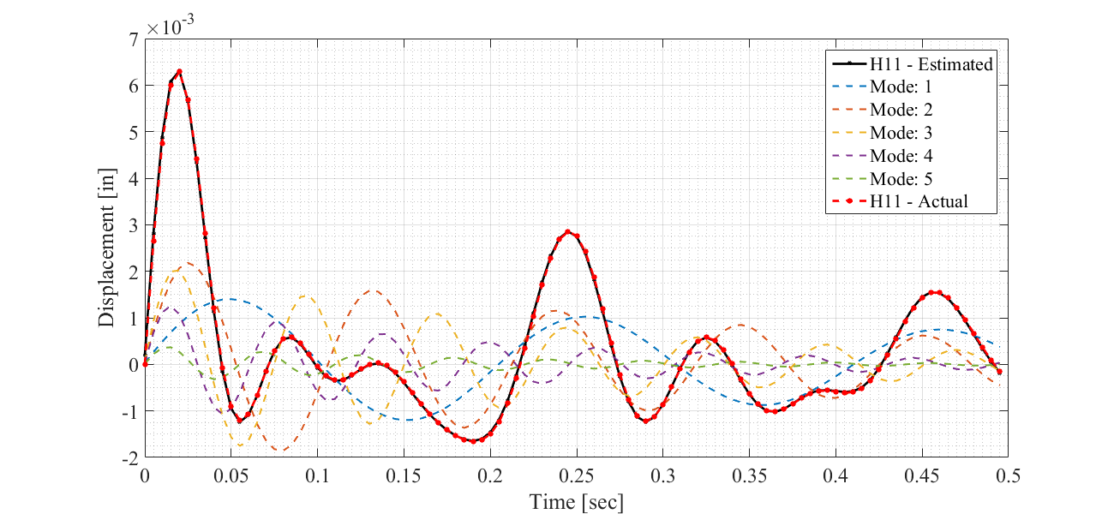

H15 Synthesis
insel = 1; % input dof index
outsel = 5; % output dof index
% FRF
fprintf('FRF\tOutput: %2d\tInput: %2d\n',out(outsel),in(insel));
% plot
[Hs,hs] = frf_synthesize(U,Lm,outsel,insel,qr,pols,w);
fh = vibsFRFplot(Hs,hs,insel,outsel,w);
hold all
% plot exact solution
% -note: outsel/insel used w/o out/in indexing
% bc hh already reduced from HH
ph = plot(fh.Children(2),w,mag2db(abs(squeeze(hh(outsel,insel,:)))),'o--r',...
'linewidth',2,...
'markersize',2,...
'displayname',['H' num2str(out(outsel)) num2str(in(insel)) ' - Actual']);
hold off
% get old strings
lh = fh.Children(1);
st = [lh.String {['H' num2str(out(outsel)) num2str(in(insel)) ' - Actual']}];
% append legend entry
st{1} = ['H' num2str(out(outsel)) num2str(in(insel)) ' - Estimated'];
legend(st);
snapnow
% Phase
fprintf('Phase\tOutput: %2d\tInput: %2d\n',out(outsel), in(insel));
% plot
[Hs,hs] = frf_synthesize(U,Lm,outsel,insel,qr,pols,w);
fh = vibsPhaseplot(Hs,hs,insel,outsel,w);
hold all
% plot exact solution
ph = plot(fh.Children(2),w,angle(squeeze(hh(outsel,insel,:)))*180/pi,'o--r',...
'linewidth',2,...
'markersize',2,...
'displayname',['H' num2str(out(outsel)) num2str(in(insel)) ' - Actual']);
hold off
% get old strings
lh = fh.Children(1);
st = [lh.String {['H' num2str(out(outsel)) num2str(in(insel)) ' - Actual']}];
% append legend entry
st{1} = ['H' num2str(out(outsel)) num2str(in(insel)) ' - Estimated'];
legend(st,'location','northeast');
snapnow
% Impulse Response Function
fprintf('IRF\tOutput: %2d\tInput: %2d\n', out(outsel), in(insel));
% plot
fs = 200; % sampling freq
l = .5; % length [sec]
[Hs,hs] = irf_synth(U,Lm,outsel,insel,qr,pols,fs,l);
fh = vibsIRFplot(Hs,hs,insel,outsel,fs,l);
hold all
% plot exact solution
h = [];
t = 0:1/fs:.5-1/fs;
for ii = 1:ne % loop poles
% get residue for mode ii
AA = Qr(ii) * V(:,ii) * V(:,ii)';
h(:,ii) = AA(out(outsel),in(insel)) * exp(pols(ii)*t) + ...
conj(AA(out(outsel),in(insel))) * exp(conj(pols(ii))*t);
end
h = sum(h,2);
ph = plot(fh.Children(2),t(1:length(h)),h,'o--r',...
'linewidth',2,...
'markersize',5,...
'markerfacecolor','r',...
'markeredgecolor','none',...
'displayname',['H' num2str(out(outsel)) num2str(in(insel)) ' - Actual']);
hold off
% get old strings
lh = fh.Children(1);
st = [lh.String {['H' num2str(out(outsel)) num2str(in(insel)) ' - Actual']}];
% append legend entry
st{1} = ['H' num2str(out(outsel)) num2str(in(insel)) ' - Estimated'];
legend(st);
snapnow
FRF Output: 5 Input: 1
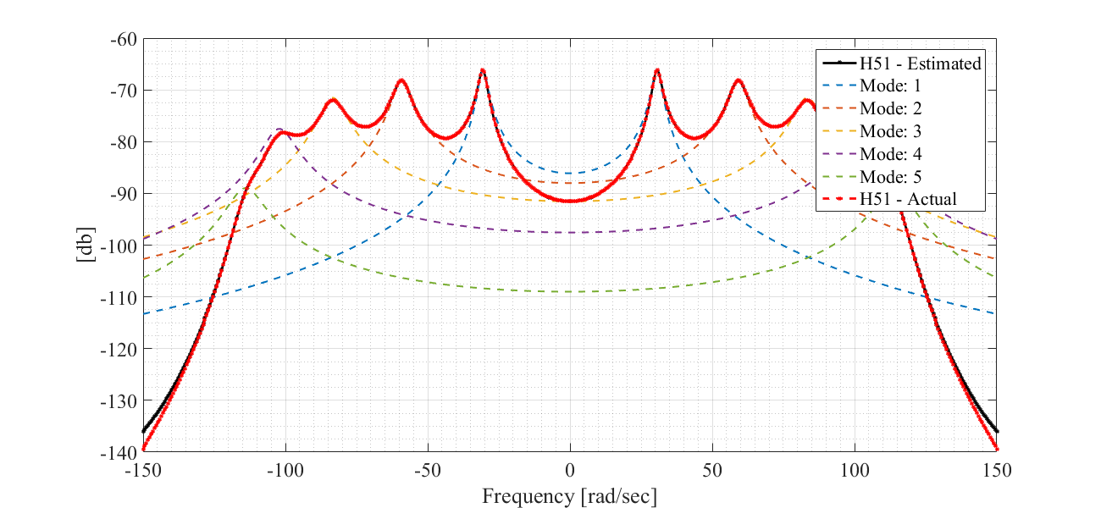
Phase Output: 5 Input: 1
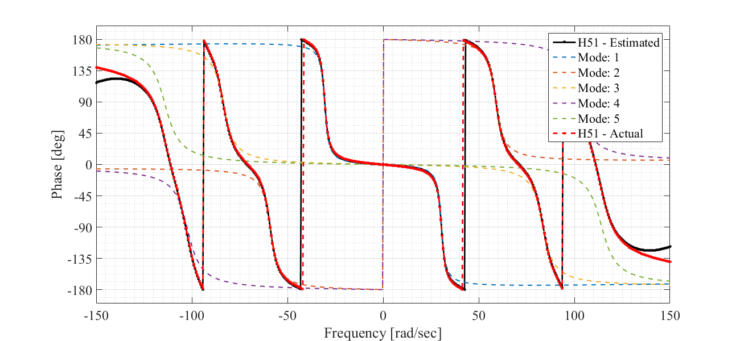
IRF Output: 5 Input: 1
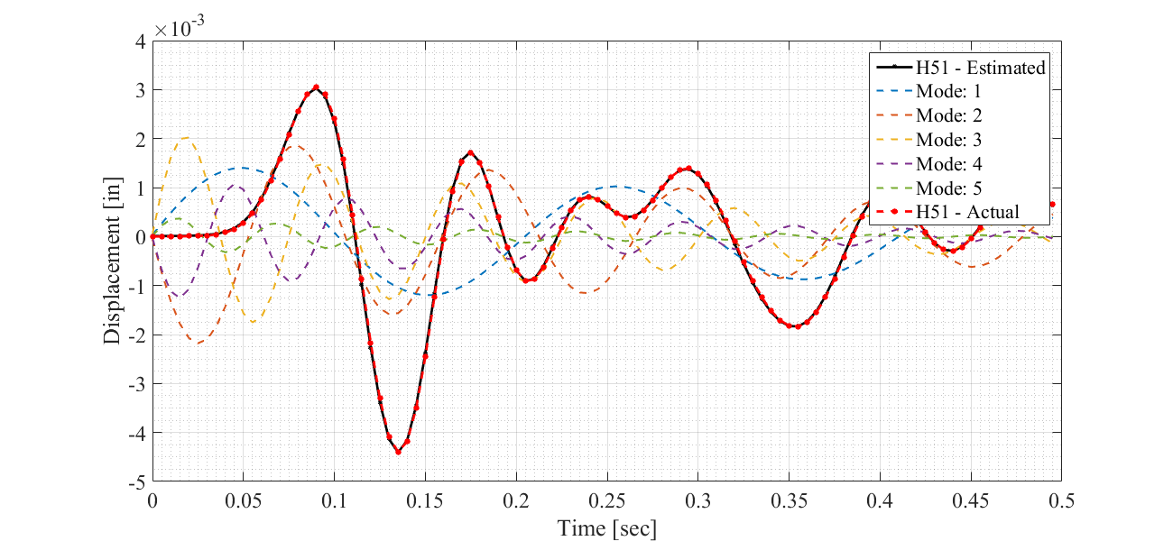

Modal Flexibility
No curvature w/o interior sampling
% pre-al
modalFlex = zeros(size(U,1),size(U,1));
% loop modes for modal flex
for ii = 1:size(U,2)
tmp = U(:,ii)*U(:,ii).'/(-1*ma(ii)*pols(ii));
modalFlex = modalFlex + tmp + conj(tmp);
end
% get deflections
f1 = zeros(length(K),1); % pre-al
f1(out) = -1e3; % apply 1kip at modal nodes ONLY
y1 = inv(K) * f1; % true solution from stiffness matrix
f2 = ones(length(modalFlex),1)*-1e3; % ULS load vector
y2 = modalFlex * f2; % modal flexibility
% plot exact solution in blue
fh = figure; ah = axes;
fh.PaperPositionMode = 'auto';
fh.Position = [100 100 1300 600];
% gather spatial coordinates
xx = linspace(0,100,nn+2); % x-dim in feet
yy = normalizeMode([y1(out) y2]); % normalize modes
yn = normalizeMode(y1);
xxo = xx(2:end-1);
xxo = xxo-xxo(1);
xxb = xxo(out);
% hold axes
hold(ah,'on');
% plot Y1 - full resolution eigenvector
plot(ah,xxo,y1(:,1),'o-k',...
'linewidth',2,...
'markeredgecolor','none',...
'markerfacecolor','k',...
'markersize',14,...
'displayname','Exact');
% plot Y2 - estimated
plot(ah,xxo(out),y2,'v--k',...
'linewidth',3,...
'markerfacecolor','k',...
'markeredgecolor','none',...
'markersize',18,...
'displayname','Estimated');
% add legend before undeformed plot
legend(ah,'location','northeast');
% plot un-deformed
plot(xxo,zeros(size(xxo)),'o:k',...
'linewidth',2,...
'markerfacecolor','none',...
'markersize',11);
hold(ah,'off');
% format
tsize = 26; % text size
xlabel(ah,'Beam Length [ft]');
ylabel(ah,'Modal Amplitude');
set(ah,'fontsize',tsize,'fontname','Times New Roman');
xlim(ah,[min(xxo)-5 max(xxo)+5])
tmp = ah.YLim;
ylim(ah,[tmp(1) abs(tmp(1))*.3]);
grid(ah,'on')
grid(ah,'minor')
box on
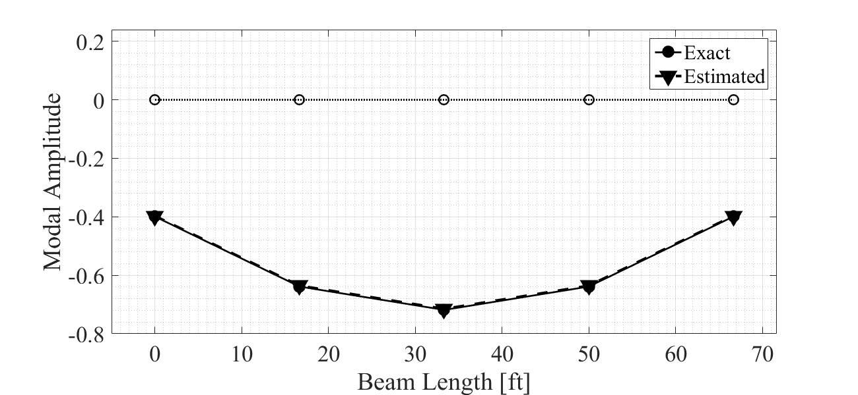

Print results
fprintf('\nTotal loads: %i %i\n', sum(f1),sum(f2))
fprintf('\nExact Displacement:\n')
fprintf('%f\n',y1)
fprintf('\nModal Prediction:\n')
fprintf('%f\n',y2)
% percent difference
tt = (y1(out) - y2) ./ y2 * 100;
fprintf('\nPercent Difference: \n');
fprintf('%2.2f\n',tt);
Total loads: -5000 -5000
Exact Displacement:
-0.399106
-0.638570
-0.718391
-0.638570
-0.399106
Modal Prediction:
-0.397220
-0.635557
-0.715005
-0.635557
-0.397220
Percent Difference:
0.47
0.47
0.47
0.47
0.47
Published with MATLAB® R2015b

